

# Alcatel 1T 7

## Type of device: Tablet

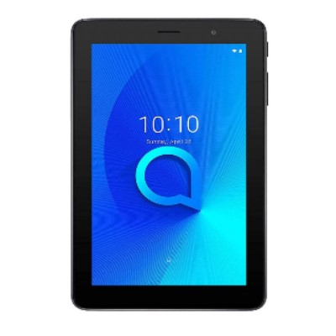

Actual Display Size : 7 inches

Operating System : Google Android

Version Number : Android 8.1 (Oreo)

Year of Release : 2018

Average Price : $133 as of 28 09 2021

Internet Access : Wi-Fi Only

## Accessibility Features:

### Cognitive

* Additional Instructions
* Copy and Paste
* Flicker Free Display
* GPS
* Photo Telephone List
* Screen Timeout Disabled
* Simple Instructions
* Simple Reminders
* Simplify Display

Voice Notes

### Hearing Impairment and Deaf

* Allows for sign language communication
* Bluetooth or Wi-Fi
* Closed Captioning
* Front Facing Camera
* Text Messaging/SMS
* Video Communications - Two-way

Visual Alerts - Incoming Calls

### Vision

* Accessibility APIs supported
* Battery Alert - Audible
* Bluetooth or Wi-Fi
* Braille Display Support
* Brightness Adjustable
* Dictation / Speech-to-Text
* High Contrast Mode
* Personalised Shortcuts
* Power Cue
* Screen Magnifier
* Screen Reader
* Text Size Adjustable
* Voice Control /Personal Assistant

Voiced Menus

### Speech

* Allows for sign language communication
* Bluetooth or Wi-Fi
* Messaging Options - Email
* Messaging Options - IM
* Messaging Options - MMS
* Predictive Text

SMS Personalisation and Reuse

### Physical

* Automatic Answer
* Bluetooth or Wi-Fi
* Dictation / Speech-to-Text
* Headset - plug connected
* Predictive Text
* Reduced hand movement option
* Speaker-phone option
* Switch control option
* Visible Focus Indicators
* Voice Control / Personal Assistant
* Voice Recognition for Accessing Features

Voice Recognition for Dialling

## How and where to get it from?

You can buy this phone from [Allphones](https://www.allphones.com.au/alcatel-1t-7-4g-android-tablet-16gb-8gb-7-prime-black), [Mobileciti](https://www.mobileciti.com.au/alcatel-1t-7-4g-android-tablet-16gb-8gb-7-prime-black), [Kogan](https://www.kogan.com/au/buy/mobile-world-alcatel-1t-7-4g-android-tablet-16gb8gb-7-prime-black-act1t7tab/), and other retailers.

## More information is available on:

[Alcatel 1T 7 4G Webpage](https://www.alcatelmobile.com/product/tablet/alcatel-1-series/alcatel-1t-7-3g/#spec)

[Alcatel 1T 7 4G User Manual (PDF Download)](https://www.alcatelmobile.com/wp-content/uploads/2019/06/1T-7-4G_Tablet_UM_EUEN_20200511.pdf)

[Alcatel 1T 7 4G Support Webpage](https://www.alcatelmobile.com/support/product-support/)